EASE VFO

Resale/LWS New Install

Order Processing Steps

Table of Contents

Order Processing Steps 1
VFO Entry – Resale/LWS New Install 2
Introduction 2
Preorder 2
Resale Orders -Overview of Telephone number assignment 2
Overview 3
LSR Form Order Entry 3
Resale/LWS New Install – Process, continued 4
Resale/LWS New Install – Process, continued 19
Resale/LWS New Install – Process, continued 20
Resale/LWS New Install – Process, continued 21
TOS and LTOS Fields 23

VFO Entry – Resale/LWS New Install

Introduction | This document provides the necessary information for the required fields and the steps to enter a resale/LWS new install request.  Important Note: Orders will vary depending on the service and features requested. This job aid is only a guideline. Refer to LSOG guidelines for a complete description of fields.

Preorder | In this document, steps for address validation on the EU form are used. See the Preorder document for validating address using the Preorder tab.

Resale Orders -Overview of Telephone number assignment | Telephone numbers for new resale install requests can be assigned in two different manners – by the system or by accessing TN Assignment from the External App Data menu.  Allowing the system to assign numbers:  - T is selected from the NOTYP drop-down.  - N is entered in the TNS field. See example below. .  - The system assigned telephone number is provided on the Confirmation form.  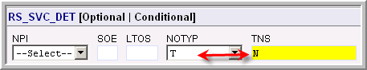  Selecting a telephone number.  Prior to selecting a telephone number from TN Assignment:  - The LSR, EU and RS page must be completed and valid.  - The PON must be saved by use of the Save icon  Once the above actions are completed:  - The TN Assignment menu item is selected from the Order tab External App Data menu.  - Specifications are filled on the TN Assignment screen.  - Once the telephone number is selected, the number can be copied and then pasted into the TNS field in EASE.  Note: TN assignment can be accessed only once per LSR. If the user needs to add additional telephone numbers after exiting TNA or if issuing Sup, the system must assign the numbers.
Continued on next page

Resale/LWS New Install - Process

Overview | The table below outlines the steps for creating a resale/LWS new install in EASE VFO. The data entered is for training purposes only and may vary according to order requirements.

LSR Form Order Entry | Take the following steps to populate the LSR form on the order.  Remember: More or less fields may be required depending on what type of order you are entering.

Step | Action
1 | With the Order List in view, roll your cursor over the Order tab and select New from the drop-down menu,  Result: The Order Initiation window appears.
2 | Select your Managed ESP company code used for submitting orders, from the Managed ESP drop-down menu.
3 | Type a PON in the Order Number field or use the pre-populated number.  Note: The PON can be up to sixteen alpha, numeric, or alpha-numeric characters.

4 | Select the applicable OCN from the OCN drop-down menu.  Note: This may or may not be the same OCN as the Managed ESP.
5 | Select the appropriate resale service type from the Service drop-down menu. (EB = Resale – MB= LWS)
6 | Select N from the Activity drop-down menu.
7 | Use the following table to determine the next step.  If Then  Using a template for the order Click the Template drop-down menu and select the applicable template name.  No template is being used Go to step 8.

Resale/LWS New Install – Process, continued

Steps (continued)

Step | Action
8 | In the LSR ADMIN section fill-in the following:  Field Description Data  LOCQTY # of service locations 1-3 characters indicating amount of locations (normally 1 or 001)  RTR Confirmation type E (only option supported by Brightspeed)  CCNA Customer Code 3 dgt customer code (CUS code)  CC Company Code (OCN) 4 digit OCN is pre-populated  Note: The ACT field will auto-populate. The DTSENT field populates when order is accepted by Brightspeed.
9 | In the Authorization section fill-in or select the following:  Field Description Data  TOS Type of Service Refer to page 23 for assistance for populating the TOS field.  SPEC Specific product Type LOOPTAG if loop tag and label is desired.  DSPTCH Dispatch Y must be selected when adding Looptag or if known truck roll.  DDD Desired Due Date Desired due date.
Continued on next page
Resale/LWS New Install – Process, continued

Steps (continued)

Step | Action
10 | The FEATURE_DET (in the LSR section) is for adding a measured access line plan type. This field is required when the third TOS field is M. See example below.  Type the plan type in the AFEATURE field.  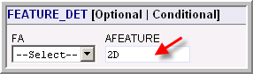  Note: Valid plan types are: 1B, 1D, 2B, 2D, 3B, 3D, 4B, 4D, 5B, OR 5D – however not all plan types are valid in every area. An error will occur if a major account for the plan type entered is not found.
11 | Scroll to the CONTACT section and fill-in the fields as noted in the table below,  Note: Information is not required in the sections above the Contact section – such as: AUTH_INFO_GRP, LSR_BILL, ADDR_GRP, BILL_NAME_CONT_GRP.  Field Description Data  INIT Who initiated the order Creator’s name  INIT TEL NO Contact telephone number Creator’s telephone number.
12 | Scroll down to the IMPCON field found after the INIT_ADDR section (no information is required in the INIT_ADDR section). Fill-in the information as shown in the table below.  Field Description Data  IMPCON Installation contact Creator or contact for the order.  IMPCON TEL NO Installation contact telephone number Creator or contact for the order.  Note: Information is not required in the sections DSGCON_ADDR, and REMARKS INFO.
Continued on next page
Resale/LWS New Install – Process, continued

Steps (continued)

Step | Action
13 | Click the EU form ICON.
14 | Use the following table to determine the next step.  If Then  Not Adding Inside Wire Maintenance Go to step 15.  Adding Inside Wire Maintenance INSIDE_WIRE_GRP section and fill in the fields as noted in the table below. Note: An S&E code for IWM3 will also need to be selected on when adding feature codes. IWM1 contract holders will not have to add a Service and Equipment. IWO Inside Wire Options U = Provide inside wiring and repair plan and bill the customer IWCON Name of person to contact regarding inside wiring Required field if IWO is selected. Type the contact name in this field. TEL_NO IWCON telephone number. Type the IWO contact telephone number.  Note: For a resale/LWS new install, no fields are required in the EU_BILL, Bill_NAME_CONT_GRP, EU_DISCONNECT_INFO, TRANSFER_OF _CALLS GRP, TRANSFER OF CALLS_SEC_GRP
Continued on next page
Resale/LWS New Install – Process, continued

Steps (continued)

Step | Action
15 | In the LOC_ACCESS section fill-in the following;  Field Description Data  LOCNUM Location number (normally 1). Note: If additional location numbers are needed for OPS (OPX MEU must be marked), click the Add link on the right of this section. 3 Character field - can be typed as 1 or 001 for example.  NAME End-user name Type in end-user’s first and last name or the business name.  AAI Additional address information such as the name of the Complex etc. Legacy Embarq converted areas and Legacy CenturyTel areas – this field is used for Unit, Floors, Bldg etc data. Legacy Embarq non-converted – this field is used for Complex address details.
16 | In the LOC_ACCESS_INFO fill-in the following fields as indicated in the able below - if access information is needed or working service exists.  Field Description Data  ACC Access information -conditional Type access directions. For example – “Locked gate, knock on east side door for entry.”  LCON Local contact -required Type contact name for access.  Tel_NO Local contact’s number -required Type access contact’s telephone number.  WSOP Working Service indicator – conditional Select: A= Additional line or V= Working Service Note: An error occurs if this field is not marked and the system detects working service.
Continued on next page
Resale/LWS New Install – Process, continued

Step | Action
17 | Scroll to the SVC ADDR GRP section and fill-in the fields as applicable for the address.  Field Description Data  AFT Drop-down to select format of address Not required unless needed.  SAPR Address number prefix Not required unless needed.  SANO Street address number Indentifies the house number.  SASF Service address suffix Indentifies the suffix for the street address.  SASD Street direction Examples: N, S, E, W, NE, NW, SE, SW  SASN Street name Examples: Street Name, Highway etc.  SATH Street type Thoroughfare portion of street address. Examples: DR, LN, ST  SASS Street Directional Suffix Identifies the directional suffix Examples: N, S, E, W, NE, NW, SE, SW  LD1 Location Designator Examples: Unit, FL (floor) etc. Note: Brightspeed in Legacy CTL or converted EQ markets, do not populate units etc in the LD or LV fields. Use the AAI field instead.  LV1 Location Value Note – Prohibited if LD1 is not populated Examples: 01, 2, 14, etc  LD2 Location Designator 2. (LD1 must be populated) Example: Wing  LV2 Location Value Note – Prohibited if LD2 is not populated Examples: 01, 2, 14, etc  LD3 Location Designator 3. (LD1/LD2 must be populated) Example: Suite  LV3 Location Value Note – Prohibited if LD3 is not populated Examples: 01, 2, 14, etc  CITY City name Type in complete city name.  STATE State abbreviation 2 character abbreviation  Zip 5 character zip code 5 character zip code.
Resale/LWS New Install – Process, continued

Steps (continued)

Step | Action
18 | Click the Validate address link to verify the address is correct.  Note: If the address is valid, no additional screens will display. For invalid addresses refer to the Job Aid on Preorder Address Validation.
19 | Click the RS (resale service) form ICON.  Note: If rotary hunt numbers are involved the HGI form must be filled in
20 | In the RS_ADMIN section fill-in the following:  Field Description Data  RSQTY Quantity of lines being installed 5 Character field - can be typed as 1 or 00001 for example.
21 | In the RS_SVC_DET section fill-in the following:  Field Description Data for training  LTOS Service type for line Not required  NOTYP Number type Select T for telephone  TNS Telephone number Type N if system is to assign. Leave blank if accessing TNA (as shown in later steps)
Continued on next page
Resale/LWS New Install – Process, continued

Steps (continued)

Step | Action
22 | In the SVC_DET_GRP section fill-in the following:  Field Description Data for training  LOCNUM Service location number 3 Character field - can be typed as 1 or 001 for example.  LNUM Indentifies the line 3 Character field - can be typed as 1 or 001 for example. Example for 1st line 1 or 001, for 2nd line, 2 or 002.  LNA Line Activity Select N for new.  Note: For multiple lines, each SVC_DET_GRP will need to be filled-in with the appropriate LOCNUM and LNUM.
23 | In the LINE_RESTRICT_2_GRP section add or fill-in the following:  Field Description Data for training  LSCP Local service freeze – Not applicable N/A  FPI Freeze PIC Select the desired Freeze option or leave blank.  PIC Interlata long distance Type in the 4 digit code or None - if no PIC  LPIC Intralata long distance Type in the 4 digit code or None- if no PIC  IPIC International PIC N/A  Note: For multiple lines, each FPI if applicable and the PIC and LPIC fields will need to be filled-in for each line.
24 | Roll your cursor over the ORDER tab, ACTION menu, and select SAVE ORDER.  (This action will allow TNA and Available Service options to be loaded based on the address.)
Continued on next page
Resale/LWS New Install – Process, continued

Steps (continued)

Step | Action
25 | Roll your cursor over the ORDER tab ACTION menu, and from the External App Data select Available Services.  Result: A new page displays with a list of the services available per the WRC and CLEC contract as shown in the example below.  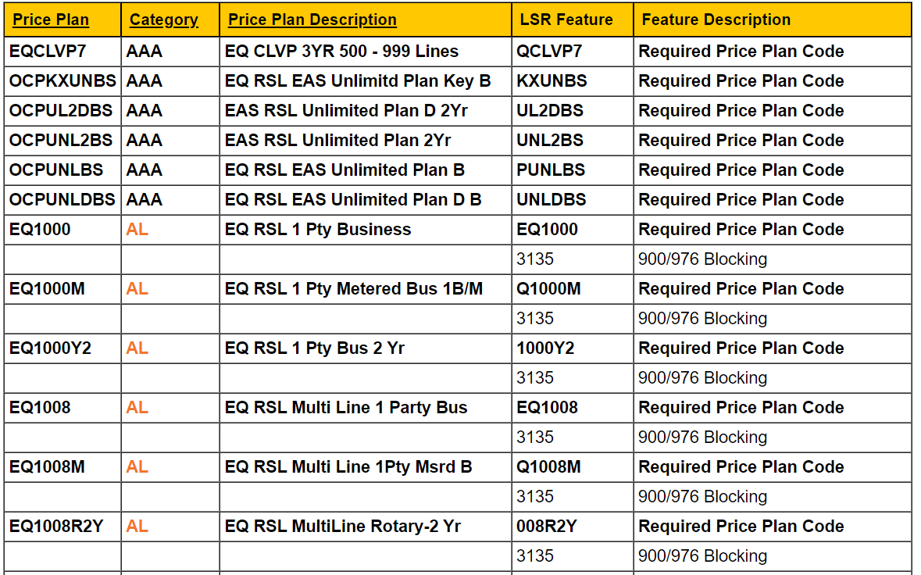
26 | Scroll to find the access line choices and copy the S&E code for the line of choice.  Note: Select a line type that corresponds with the TOS entered.
Resale New/LWS Install – Process, continued

Steps (continued)

Step |  | Action
27 | Click back on EASE VFO and paste the S&E code in the FEATURE field.  Note: Feature details – if the feature requires detail information such as call forward no answer or busy, the telephone number to be program on the feature must be added in the Feature Detail field.  Call Forward No Answer feature detail information:  If the field starts with 1 (for long distance numbers), the first 11 characters are programmed as the call forward number and the 12th and additional characters as the number of rings.  If the field does not start with 1, the first 10 characters are programmed as the call forward number and the 11th and additional characters as the number of rings.  Example of a local call forward no answer with 3 rings.  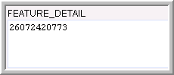
28 | On the right of the Feature Grp field, type in the number of additional features to be added. See example below.  Click on Add and the corresponding number of new feature sections is added to the RS form in which to paste additional features.  Note: You can still add or remove feature fields if need be by using the Add or Remove Section(s).
29 | For additional features and/or blocks - click on Available Services Look-up screen and repeat steps 20-22 to add all requested features.
Continued on next page
Resale/LWS New Install – Process, continued

Steps (continued)

Step | Action
30 | Use the following table to determine the next step.  If the order is for Then  Multiple lines Go to step 31.  Single line Go to step 33.
31 | On the right-hand of the RS_SVC_DET header type in the additional number of extra lines needed (1 is the default).
32 | Determine the next step by using the table below.  If Then  The added sections are to be blank Click the ADD link. Note: This process will add the same number of feature fields but they will be blank.  Same features, PICS from the first line apply to additional lines Click the COPY link. Note: When copying the data, the LNUM in the new SVC_DET_GRP section must be changed to represent the new line number.  Result: New sections are added beginning with the RS_SVC_DET section. You will need to scroll down to view each newly added new section.  Notice on the screen print below, that the new RS_SVC_DET section is numbered as (2) and that there is only an option on the right to remove the section.  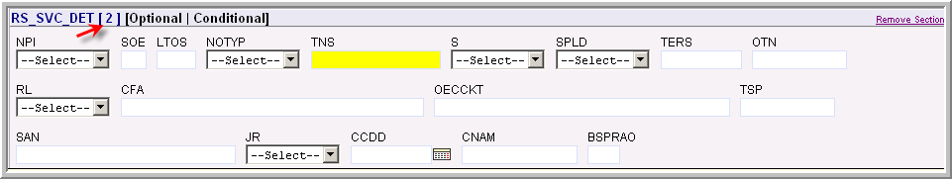  Notice on the screen print below, that the last RS_SVR_DET section added is numbered as (3) and the ADD and Copy options are present.  After the sections are added add or change the data as needed. Remember that the appropriate telephone number will need to be added to the TNS field if using TNA.
Resale/LWS New Install – Process, continued

Steps (continued)

Step | Action
33 | Use the following table to determine the next step.  If Then  Allowing system to select the telephone number - T is selected from the NOTYP drop-down. - N is entered in the TNS field. Type T in the TNS field - Go to step 41 Remember – Numbers auto-assigned will be provided on the confirmation form. When listings are wanted, directory listing requests must be submitted after order completion  Assigning telephone numbers Go to step 34.
Continued on next page
Resale/LWS New Install – Process, continued

LSR Form Order Entry (continued)

Step | Action
34 | Roll your cursor over the ORDER tab, EXTERNAL APP DATA menu, and select TN Assignment.  Result: The TNA screen for Brightspeed in Legacy CTL and Legacy EQ converted market displays as shown below:  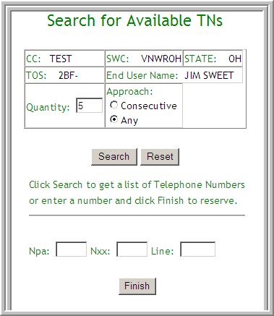  Or  Result: The TNA screen for Legacy EQ displays as shown below:  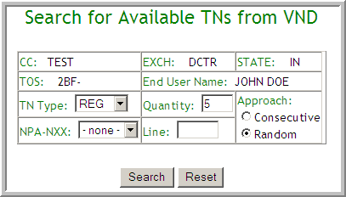
Continued on next page
Resale/LWS New Install – Process, continued

Steps (continued)

Step | Action
35 | On the TN Assignment screen fill-in or select the following:  Field Description Data  TN type (Legacy EQ only) Drop down menu with lists of the types of numbers Default is REG – change if necessary.  Qty Amount of numbers to return – default is 5 If more than five change the quantity Note: Quantity cannot be greater than a block of 10 when searching for consecutive numbers.  Consecutive Allows user to select multiple numbers in sequential order Do not mark (unless installing more than 1 line and want numbers in consecutive order)  NPA-NXX (Legacy EQ only) Area code – Available prefixes Select choice  Line (Legacy EQ only) Allows a search on a particular telephone number Telephone number Note: If no data is returned on the search, the telephone number is not available.  Npa – Nxx –Line (Brightspeed) markets only Allows a search on a particular telephone number Telephone number Note: If no data is returned on the search, the telephone number is not available.  Remember - TNA can only be accessed once on any LSR – including any SUPS. If a SUP requires an additional telephone number, the system must assign it.
Continued on next page
Resale/LWS New Install – Process, continued

LSR Form Order Entry (continued)

Step | Action
36 | Click the Search button.  Result: TNA returns the TN’s matching criteria (if criteria can be met) as shown in the example below.  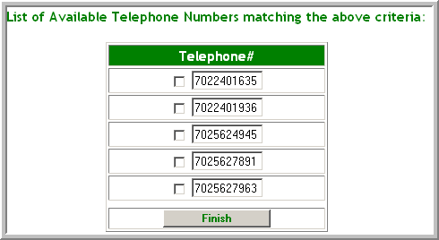
37 | Check the number(s) desired for the PON and click the Finish button.  Result: The numbers selected are displayed in a new window and ready to be copied as shown in the example below.  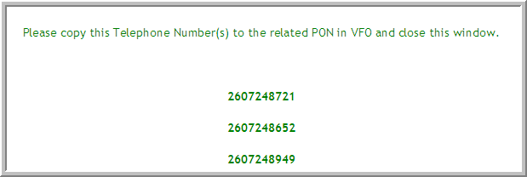
Continued on next page
Resale/LWS New Install – Process, continued

LSR Form Order Entry (continued)

Step |  | Action
38 | Copy the number.  IMPORTANT: When multiple numbers are needed – each number must be copied and then pasted. Do not close out of this window until all numbers are copied or at least written down as once the window is closed it cannot be accessed again. Suggestion: For multiple lines - copy and paste numbers into a Word document to avoid the time elapsing.  In Legacy EQ - TNA begins timing as soon as accessed and numbers must be selected within 20 minutes.
39 | Paste the new TN(s) in the TNS field on the RS_SVC_DET section(s) of the RS form
40 | Click the X on the telephone number window.  Result: TNA is exited.
Continued on next page

Resale/LWS New Install – Process, continued

Steps (continued)

Step | Action
41 | Use the following table to determine the next step.  If Then  A straight-line directory listing is needed Note: Directions for captions listings will be provided in a future job-aid that will be posted to the Wholesale site. Click the DL form ICON, and go to step 42.  A directory listing is not needed Go to step 45.
42 | In the LISTING_CNTRL section of the DL form fill-in or select the following data for each field:  Field Data  LACT (Listing Activitiy) N (New)  RTY (Record Type) LML (Local Main Listing) 1st Character: F=Foreign L=Local S=Secondary Listing 2nd Character: AL=Additional Listing AM=Additional Main AU=Alternate user listing CM=Client main CR=Cross-reference listing ML=Main listing  LTY (Listing Type) Valid Values: 1=Listed, 2=Non-listed, 3=Non-published, 4=Non-published emergency, 5=Non-published special, 6=Omit DA, 7=No appearance, 8=Temporary listing.  STYC SL (Straight Line)  TOA (Type of Account) R (Residential) or B (Business)  DOI (Degree of Indent) 0 (Zero) for straight-line listings.  LOCNUM (Location Number) 3 Character field - can be typed as 1 or 001 for example.  DL Number (DLNUM) 3 Character field - can be typed as 1 or 001 for example. Note: If adding multiple straight-line listings the DL will increase by one for each listing.
Continued on next page

Resale/LWS New Install – Process, continued

Steps (continued)

Step | Action
43 | In the LISTING_IND section of the DL form fill-in or select the following data for each field:  Field Data  DirName Populate with the directory name.  Also –  If Then  The listing is a dual listing (two first and/or last names will be listed together). Select Y in the DLNM (Dual Listing) field, and go to step 44.  The listing is not a dual listing Go to step 44.
44 | In the LISTING INSTRUCTION section fill-in the following data if needed.  Field Data  LTN (Listed TN) End-users TN to be listed. Note: If allowing the system to select a telephone number, (TNA was not used), enter an N is this field. Note: If the telephone number is a non-standard number such as an 800 number, the TN is entered in the NSTN field.  PLA (Place Listing As) Indicates how a listing with a numerical value will be alphabetized. Type complete listing in word form Example – The listing of - 1040 Tax - could be alphabetized in the directory as One Zero Forty Tax, Ten Forty Tax, depending on the wording used in the PLA field. .

Resale/LWS New Install – Process, continued

Steps (continued)

Step | Action
45 | In the LIST_NAME_GRP section fill-in the following data if needed.  Field Data  LNLN (Listed Last Name) End-user’s last name or if a business the first word of the business name. Note: If the business name begins with ‘The’, they may wish for ‘The’ to fall at the end rather than the beginning of the listing.  LNFN (Listed First Name) The end-user’s first name(s) or the remaining words of the business name.
46 | In the LIST_ADDR_GRP section fill-in the following data if needed.  Field Data  LANO HSN  LASF FRACTION  LASD DIRECTION  LASN STREET NAME  LATH TYPE  LASS SUFFIX  LALO N/A  LALOC CITY  LAST STATE  LAZC ZIP CODE  ADI O = Omit address in DA and directory
47 | In the ADVERTISING section fill-in the following data if needed (Business Only).  Field Data  YPHV Classified heading identifier number. Note: The classified heading numbers can be found at www.rhd.com/telco
48 | Click the green checkmark ICON on the top right of the order.  Result: The order goes through an error check.
Continued on next page
Resale/LWS New Install – Process, continued

Steps (continued)

Step | Action
49 | Determine the next step by utilizing the table below.  If Then  An Error box displays. Correct the errors indentified. Note: The STATUS field on the order states Errored as shown below.  No Error box displays The status will state Validated and you are ready to submit the order.
50 | Click the running man ICON to submit the order.  Result: The Status field on the order will change to Sent, then to Submitted
51 | Congratulations! You have now completed the steps to complete a basic New Install order. Remember more forms may be required depending on the order type.

TOS and LTOS Fields

First Character (type) | Second Character (product) | Third Character (class) | Fourth Character (characterization)
1 = Business  2 = Residence  3 = Government (Not supported by Brightspeed)  4 = Coin | A = Multiline/Keyline  B = Single line  C = Coin  D = Advanced services  E = CENTREX resale  H = ISDN (BRI)  J = PBX (trunk)  K = ISDN (PRI)  Q = DID/DOD  R = Data voice shared line (Line Sharing) | M = Measured rate  F = Flat rate | F = Foreign Exchange Service (FXS)  R = RCF  W = WATS  - = Not applicable

